Theory of computations-CSA1354

NAME:S.Revathi

Reg.no:192011467

Slot-A

1.Design dfa to accept bcaaaaaa,bc and, c

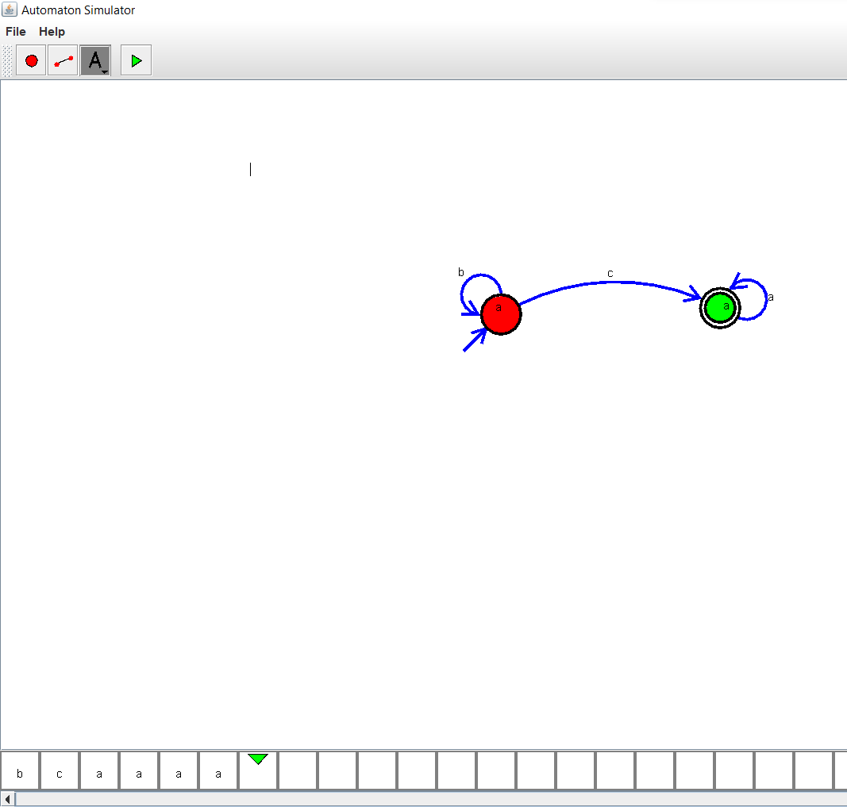

2)nfa to accept aaaaaa\

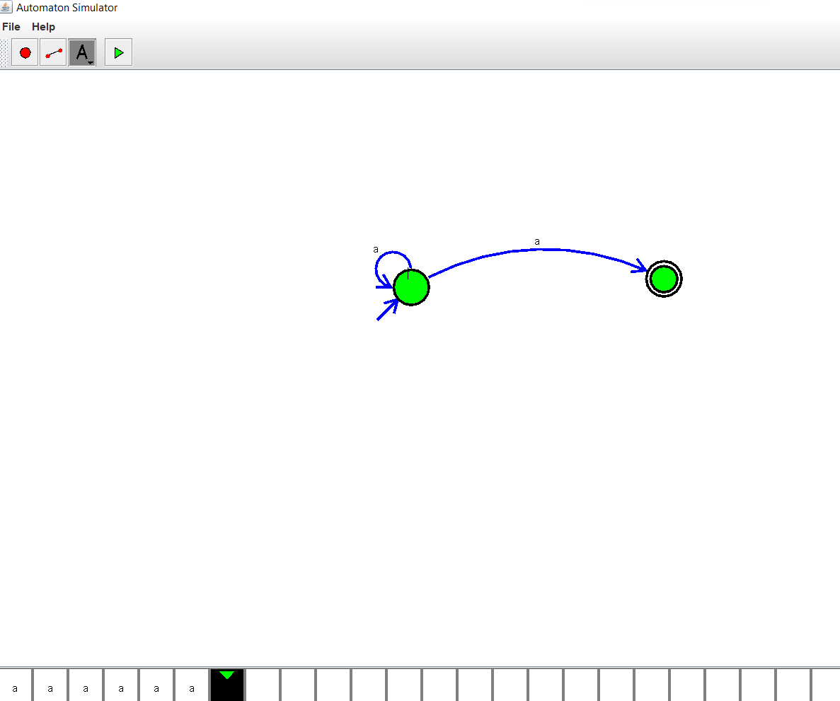

3)pda-a^nb^n

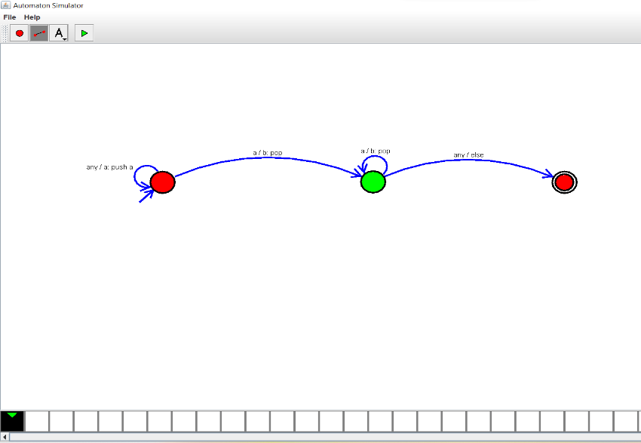

4)Design tm for input a^nb^n

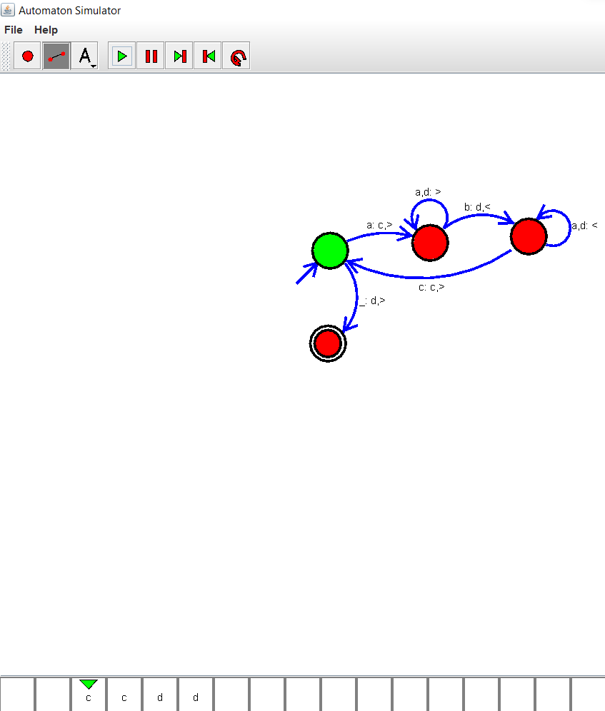

5)Design pda for input aabbbc(l=a^nb^n2n)

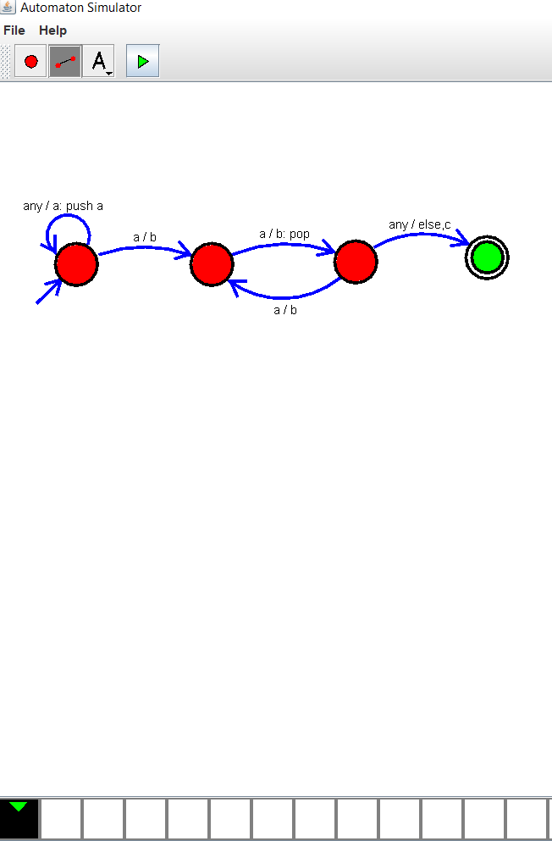

6)TM Simulator for palindrome w=ababa c

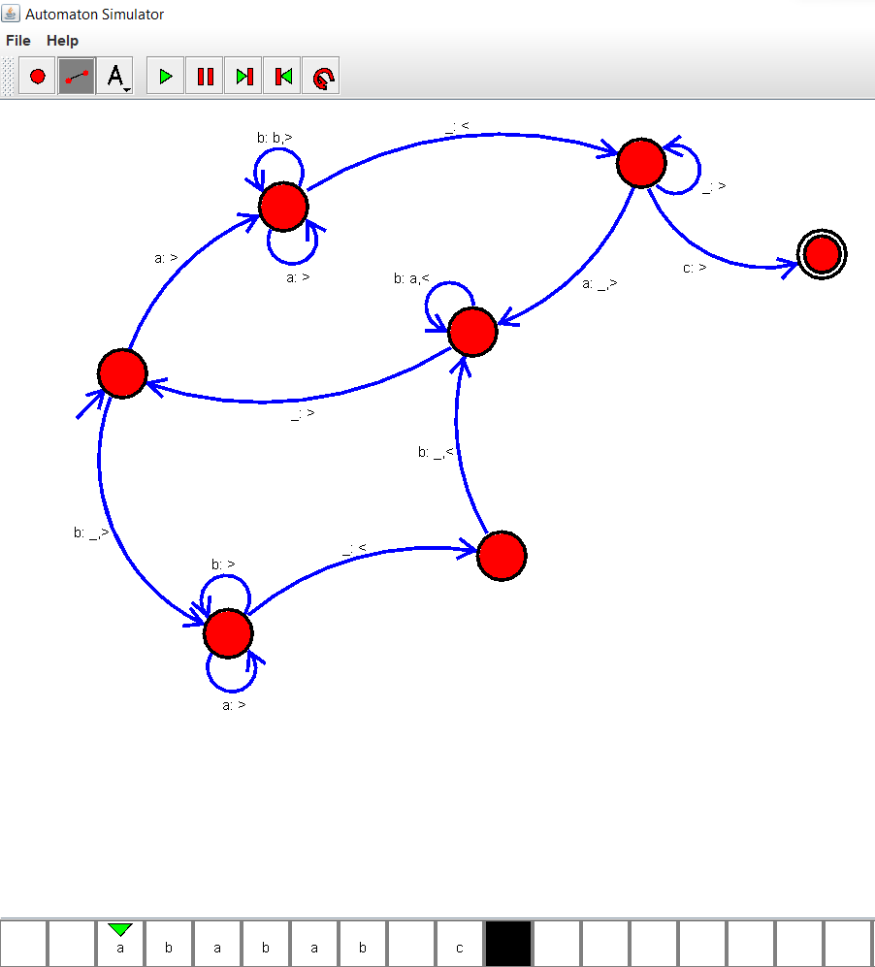

7)Design Tm to perform addition of following

w=aa +aaa

after addition of a’s =aaaaaa

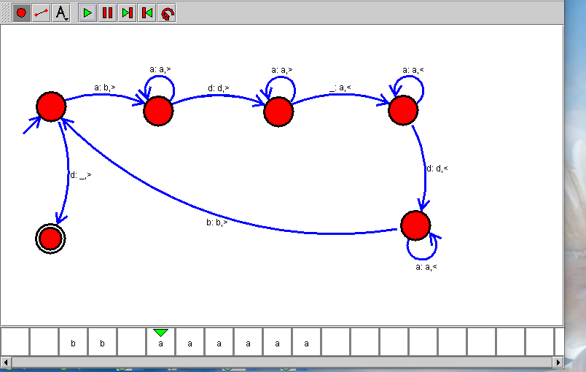

8)Design Tm to perform subtraction

W=aaa-aa

The result of substraction is = a

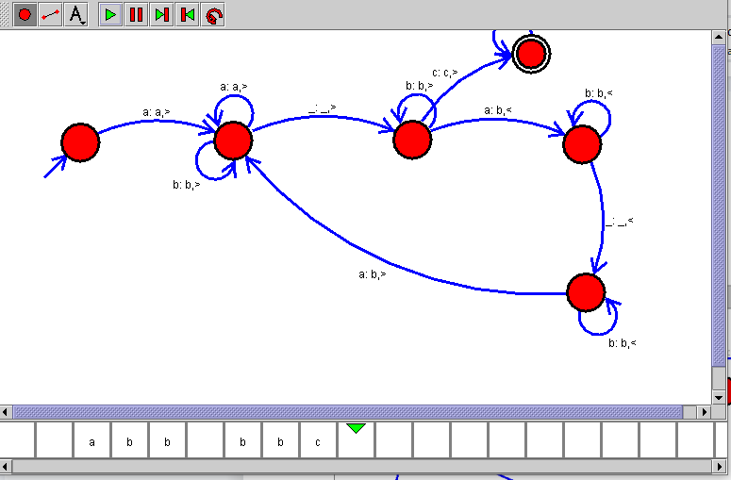

9.Design TM to perofrm string comparison

W = aba aba

